# Program Selector

## Description

The purpose of this program is to allow a District manager to select one of the multiple programs featured in the Food Giant Flyer Creator

## Operation

If you are a district manager, you will see the following window when you run the Food Giant Flyer Creator Program

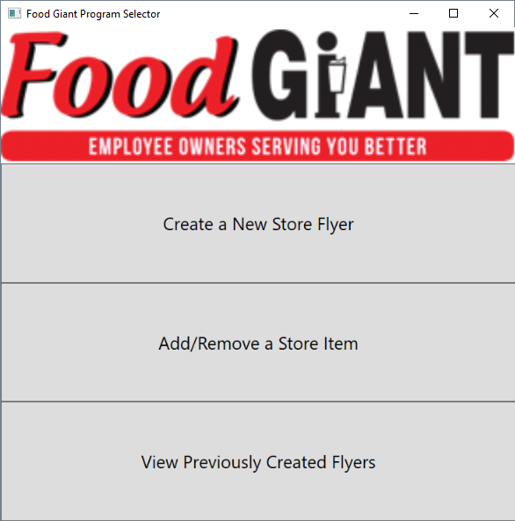

Figure 1 Program Selector

Simply click the button of the program you want to open.

Once you are done with the selected program, you can close that program’s window and still open a different program from the Program Selector.

# Flyer Creator

## Description

This program is designed to allow a store or district manager to generate a store flyer.

## Setting the flyer information

First, select the number of flyer items you wish to display

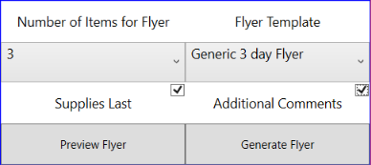

## Entering the Store Information

Fill in all available fields

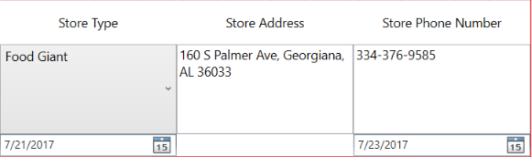

## Entering the Flyer Item Information

Click the left drop down list to select from one of the store items used by Food Giant.

Note: If the item you need to use is missing, please call a district manager so they can add that item in.

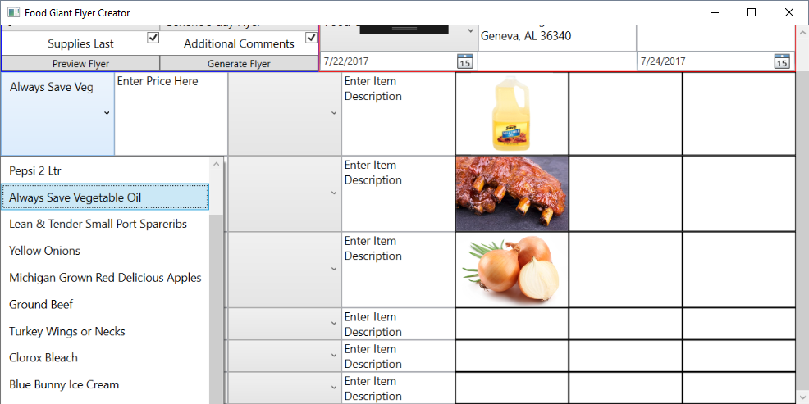

Once you select an item, enter in the discounted sale price for the item. Either enter the item in as it’s dollar price “$#.##” or how many items for how much “#/#”.

Next, select the size of the item. Note: Click the Custom option to enter in your own size type if it is not in the list.

Next, enter in the item description. If you do not have an item description to enter in, delete the data in the box

Select an image for the flyer to display for that item. You can only select one image. Selecting the image draws a gold banner around the image you have selected.

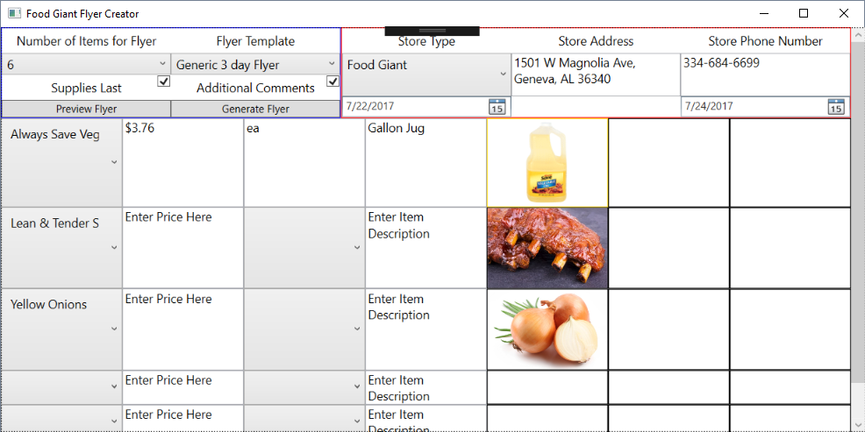

Click Generate Flyer to populate the flyer values into a complete flyer

## Printing the flyer

To print the flyer, click the Print button at the top of the page. It’s recommended that you “save as pdf” instead of just printing the flyer, so you can make easily make more copies later.

# Flyer History

## Description

This program allows a District Manager to view previously-created store flyers.

You have multiple options to find a store flyer: Find all flyers, find all flyers created by a user, or find all flyers by start, end or creation date.

After clicking a one of the above options, click the drop down box to see a list of all created flyers.

Select the flyer you want then click the “” button.

The previously created flyer will be populated in a new window.

# Database Maintainer

## Description

This program allows a district manager to add new items to the database, which are populated in the Flyer Creator Program.

## Entering in a new Database Item